Customer:  B  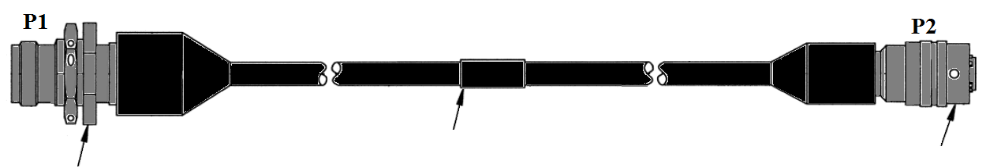  B    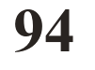   |  |  |  |  |  |  |  |  |  |  |  |  |  |  | Date:
Manual: | Type: O&M |  |  |  | Type: CMM |  |  |  |  |  | Manual Revision: |  |  |  |  | Revision Date:
 | Number: |  |  |  | Number:
Section: |  |  |  | Page: |  |  |  |  |  |  |  | Para:
Figure: |  |  |  | Table: |  |  |  |  | Part Number:
Discrepancy (Provide as much detail as possible):

Initiator: |  |  |  |  |  |  |  | Title:
Submit to: B-E Customer Services.
via email B-Ecustomerservices@breeze-eastern.com

Breeze Eastern Use Only
Engineering Services Disposition:

Engineering Services: |  |  |  |  |  |  |  |  |  |  |  |  | Date:
Customer Services: |  |  |  |  |  |  |  |  |  |  |  |  | Date:
BE-Tracking #

Customer:  1 |  |  |  |  |  |  |  |  |  |  |  |  |  |  |  |  |  |  |  | Date: | 2  16
Manual: | Type: O&M  3 |  |  |  |  |  | Type: CMM  3 |  |  |  |  |  |  | Manual Revision: |  | 4 |  | Revision Date:  8 |  |  |  | 5
 | Number:  6 |  |  |  |  |  | Number:  7
Section:  9 |  |  |  |  |  | Page: |  |  |  |  |  |  |  |  | Para: |  | 11
Figure: |  |  |  |  |  | Table: |  |  | 10 |  |  | Part Number:
Discrepancy (Provide as much detail as possible):

12

1212
DO NOT RETURN THESE INSTRUCTIONS TO BREEZE-EASTERN
14
13
Initiator: |  |  |  |  |  |  |  |  |  |  | Title:
Submit to: B-E Customer Services.
via email BEcustomerservices@breeze-eastern.com

Breeze Eastern Use Only
Engineering Services Disposition:

15
18
17
Engineering Services: |  |  |  |  |  |  |  |  |  |  |  |  |  |  |  | Date:
Customer Services: |  |  |  |  | 19 |  |  |  |  |  |  |  |  |  |  | Date: |  |  | 20

21

INSTRUCTIONS: DO NOT RETURN THESE INSTRUCTIONS TO BREEZE-EASTERN
Items 1 through 14 to be completed by Initiator and items 15 onward will be completed by Breeze Eastern.

- Customer’s Name (end user).
- Date submitted by originator of the form.
- Manual type & number in question
{Example: - Operations & Maintenance (O&M) / Number TD-94-002 or Component Maintenance Manual (CMM) / Number TD-94-009}.
- Manual Revision.
- Revision Date of the manual.
- Section reference within the manual (if applicable).
- Page number/s.
- Paragraph reference (if applicable).
- Figure reference (if applicable).
- Table reference (if applicable).
- Part number affected (if applicable).
- Discrepancies provide as much detail as possible.
- Initiator’s full name.
- Title/position of the initiator.
- Engineering Services Disposition.
- Tracking number.
NOTE: Number will only be created if it is confirmed that the manual revision is required.
Tracking number is created as follows:
2-digit year that the manual was first issued, and the 3-digit sequence number of each manual produced that year. First manual in each year is -001.

This is TD YYXXX TPDR MMDDYY XXX

Manual reference TPDR Issue Date
3-digit sequence numbers based on how many TPDRs are already appended to this manual. If this is the first, sequence is 001.

Example: TD94002TPDR112203002

- Name of person in Engineering Services that provided the disposition.
- Date completed the disposition
- Names of Customer Services recipients of TPDR.
- Date TPDR was forwarded to Customer Services for distribution.
- Additional data & disposition if required.

Breeze-Eastern LLC Phone: (973) 602-1001
35 Melanie Lane Email: B-Ecustomerservices@breeze-eastern.com
Whippany, New Jersey 07981-1638 Web site: www.breeze-eastern.com
Attention: Customer Services

